**Architecture Design**

Software design is the process of implementing software solution to one or more seats of problems. Software design usually involves problem solving and planning a software solution. The includes both a low-level component and algorithm design and a high-level architecture design.

**Data flow Diagram:**

A data flow diagram is a graphical representation of the flow of data through an information system, modelling its process aspects. It is often used as a preliminary step to create an overview of the system, which can later be elaborated. It also shows what kind of information will be input to and output from the system, where the data will come from and go to, and where the data will be stored.

DFD Level-0:

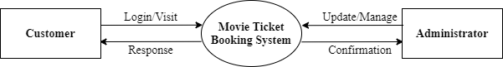

DFD Level-1:

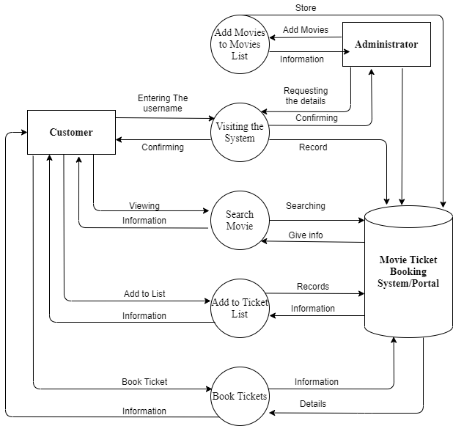

**Entity-Relation Diagram:**

